1. **Previous works**

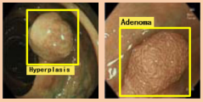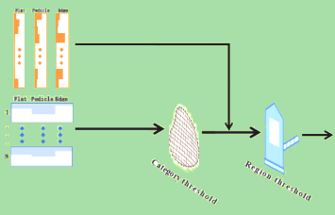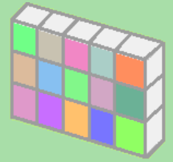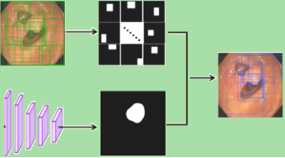

**Inadequate**

**classification**

Bi-category

**[Junbo Gao](https://pubmed.ncbi.nlm.nih.gov/?term=Gao+J&cauthor_id=35103073) et al.[21]**



Presence

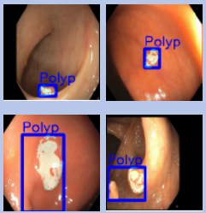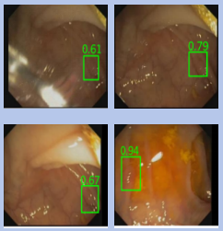

**[Lingyun Wu](https://link.springer.com/chapter/10.1007/978-3-030-87240-3_29" \l "auth-Lingyun-Wu) et al.[21]**

**[A Mohammed](https://xueshu.baidu.com/s?wd=author:(A Mohammed) &tn=SE_baiduxueshu_c1gjeupa&ie=utf-8&sc_f_para=sc_hilight=person" \t "https://xueshu.baidu.com/usercenter/paper/_blank) et al.[21]**

**Our work**

**c) Our contribution and results**

**Solution1**

**Solution2**

**Solution3**

**Space category module**

**Contribution 2**

**Cross-reference module**

**Contribution 1**

**Contribution 3**

**Dual-threshold Postprocessing Strategy**

**Our**

**results**

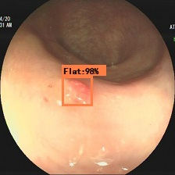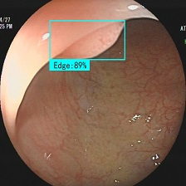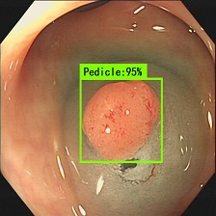

**Challenges**

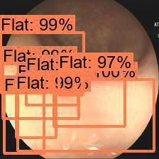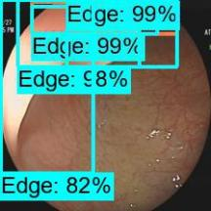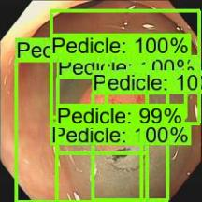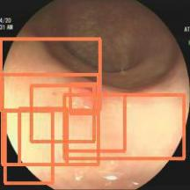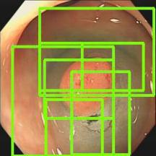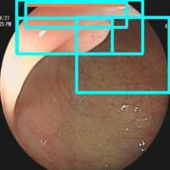

**Challenge 3**

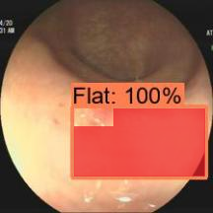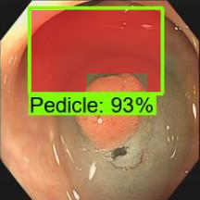

**Unexpected background areas**

**Undistinguish-ed confifence level**

**High false positive prediction**

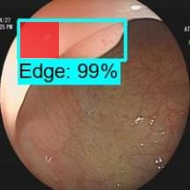

**Challenge 1**

**Challenge 2**

1. **Challenges in weakly supervised polyp detection**